Bunbury Mill
Fault & Findings Report for:
Squeaking end bearing on Horizontal shaft
Fault
During mill opening on Sunday 27/08/2023 a noise was heard from the bearing ref below. No heat was detected so mill continued to run. This report records the findings of the work carried on Wednesday 30th
Present: Mike, Barry, Paul, Ken,
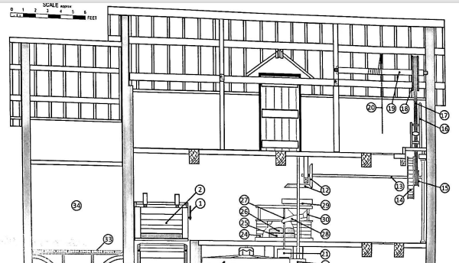
Findings
No movement was detected when the shaft was rocked, conclusion was bearing did not have excessive wear. The upper bearing cap was removed (Noted as securing nuts were slightly loose). Grease was blackish in colour but thought not to be through heat but more likely through age as this bearing had not been stripped down to this level in some time (Years).
The bearing shells were not remove as it appeared to be a shaft tube shell. This method of shaft bearing could have been a previous repair if split shells were not available. Further investigation required to confirm type used as currently it is not a normal arrangement.
It was noted that the outer surface of this tube showed varying wear marks across half its length.
New grease was applied to the bearing and top cap installed, securing nuts were “nipped up”.
The mill was started, shaft engaged and no further squeaking was heard.

Supporting photos
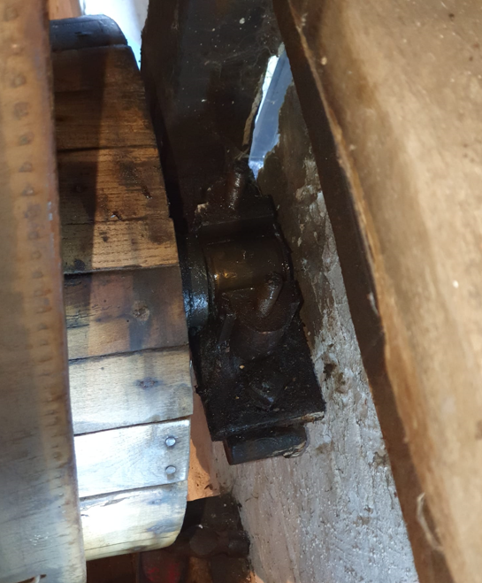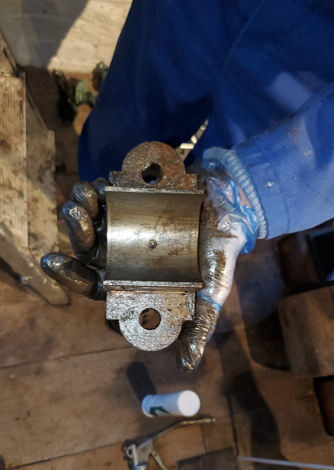
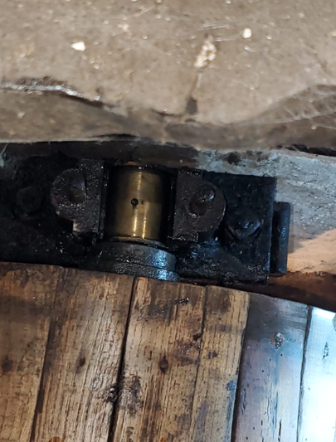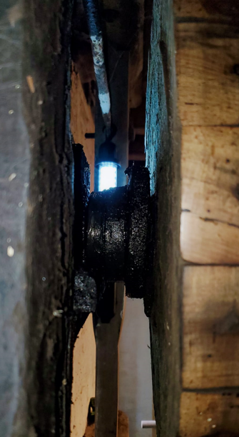

Follow up
- Monitor performance to see if any further noise is heard.
- Install grease nipple in cap to aid future maintenance.
- Investigate bearing shell design.

